Review the article below, do additional research and answer these questions. You should prepare your report according to this format:

Introduction/Context (write about one page summarizing the case; include the context and key questions raised in it)

Q1 (list the question)
A1 (your answer)
Etc.

Conclusion (write no more than one page of your conclusions and observations)

Work cited

Use list (bullets), graphs, charts, tables, etc. to make your report more effective (a sample is on Blackboard). Be sure to use data available in the Case supplemented with additional research. Your report must be between 4 and 5 pages, 1.5 space with font TNR11

*********************************************************

QUESTIONS:
1. How is Hewlett-Packard trying to divide itself into two? Along which lines will the corporate units be split up? What will each of the two new corporate entities sell?
2. In terms of strategy formulation, what is the rationale for the split-up? How convincing does the case seem to be? How much of a panacea can this demerger be?
3. In terms of strategy implementation, is the case compelling enough, in your opinion, to justify all the trauma of splitting up of the corporation into two parts? What are some of the biggest downsides and disadvantages of the demerger? How easily can they be compensated for and outweighed by the advantages of the demerger?

As H-P Split Nears, Bosses Tick Off a Surgery Checklist

Information chief oversees plan to ensure business separation goes smoothly for employees, customers
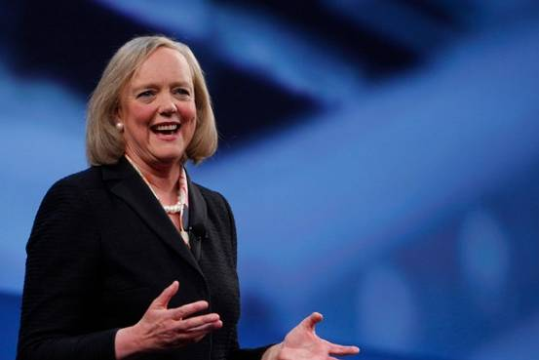ENLARGE
HP CEO Meg Whitman will soon lay out the financial underpinnings of the computer giant’s split into two separate companies. PHOTO: HEWLETT-PACKARD INC.
By
ROBERT MCMILLAN
Updated June 30, 2015 1:53 p.m. ET
36 COMMENTS
Later this week, Hewlett-Packard Co. will disclose for the first time the financial outlines of its successor companies: HP Inc., which will sell PCs and printers, and Hewlett-Packard Enterprise, a supplier of corporate technology.
Separating the balance sheets is just the beginning of a complex surgery. Scott Spradley, chief information officer at the current H-P, soon will hit the start button on a global network of command centers designed to keep operations running amid an arduous four-month-long and $1.8 billion restructuring effort.
Computer systems are the lifeblood of H-P, and Mr. Spradley’s job is to ensure that his team of surgeons can safely divide a company with $111.5 billion in annual revenue, spanning 600 locations in 170 countries.
That means cloning 2,600 internal computer programs—including human resources systems, supply chain forms—separating their data and restarting them.
If anything goes wrong, it could stall the split, and that would undermine H-P’s credibility in investors’ eyes.
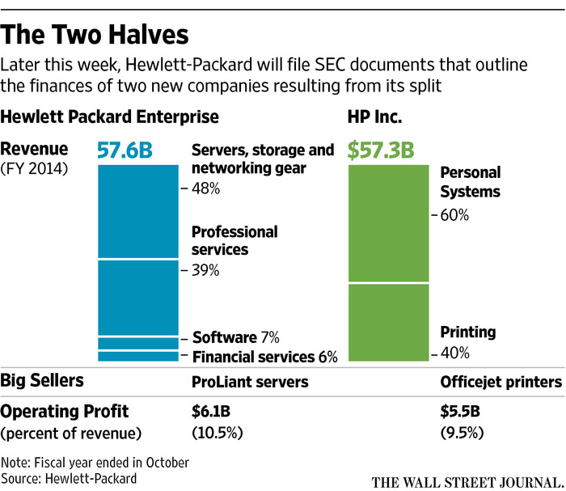ENLARGE
If the company’s computer systems fail, H-P employees might not get paid, its customers might not be able to order, and its partners could be unable to communicate.
Mr. Spradley, who favors tortoise shell glasses and silver cuff links in the staid world of H-P, doesn’t easily sit still. He clicks his pen restlessly as the milestones drone on, suddenly jumping to a white board to explain a data migration plan. There have been a lot of bugs, but things are smoothing out. “We’re a second half team,” he adds. He is a key executive on a 500-person Separation Management Office team.
Its seemingly endless checklist must ensure the new companies can comply with Swiss workplace laws, file legal documents for new companies in China, post new logos on websites. It also must physically separate employees from the two companies while simultaneously allowing them universal access to their Palo Alto, Calif. offices.
“This is the creation of two new, equally-sized companies,” H-P Chief Executive Meg Whitman said in an interview. “You can’t hire people to tell you how to do this because, honestly, it has never been done before.”
It isn’t the first time H-P contemplated a split. In 2011, Ms. Whitman’s predecessor, Leo Apotheker, floated the idea of spinning off H-P’s PC division, a move that rival International Business Machines Corp. had made nearly a decade earlier. Mr. Apotheker announced the plan during a day that included an earnings miss, a plan to quit smartphone and tablet businesses, and the $10.3 billion acquisition of Autonomy, a British maker of analytics software.
H-P’s stock dropped 20% the following day.
Three months later, Ms. Whitman sat in Mr. Apotheker’s former office and said there was “no question” H-P was better off as one company.
That view began to shift in early 2014. Ms. Whitman had pledged to cut 55,000 positions, soothed anxious investors and boosted employee morale, but she hadn’t expanded the company’s revenue.
In a series of meetings in Palo Alto, Calif., H-P executives tossed out ways to improve their lines of business. Where would printer ink be in five years? Laser printers? Consumer PCs? Servers?
The group quickly realized they needed to adapt two different strategies to expand the company’s consumer and corporate businesses.
‘We keep coming back and saying…they can stand alone as two Fortune 50 businesses.’
—Bill Veghte, Enterprise Group GM
With limited prospects for growth, the Personal Systems Group could use the printer business’ high profits to spin cash while tiptoeing into new markets such as 3-D printing or virtual reality hardware.
The Enterprise Group, in contrast, played in a fast-changing market where cloud computing and crumbling margins threatened the company’s core hardware business. If H-P could become a one-stop shop for corporate hardware, it could boost margins by selling software for security and private cloud computing.
“We keep coming back and saying, the businesses are strong enough, the leadership team is good, the operating model is in place, they can stand alone as two Fortune 50 businesses,” recalled H-P Enterprise Group General Manager Bill Veghte. “And so, the fascinating thing is, we started having discussions with the board about it.”
Over the next six months—and during 17 meetings in total—H-P’s board mulled various proposals.
“It became clear, as we looked at various alternatives and scenarios, that separating into two still very large but more focused and more agile companies would allow for us to accelerate the ability to create value for customers, to compete, and obviously create value for shareholders,” said Patricia Russo, a board member and a former CEO of Alcatel Lucent.
‘The split is likely to be value-creating for H-P shareholders near-term [but] is not a magic solution…’
—Toni Sacconaghi, Sanford C. Bernstein analyst
Another factor: In October 2013, Ms. Whitman lifted H-P’s share price nearly 10% by saying she expected revenue to stabilize in 2014 and the business world grow in 2015. By late 2014, though, it wasn’t happening. H-P’s 2014 revenues were down from 2013, and the slide has continued during the first two quarters of fiscal 2015.
“I think she was looking to do something—remember, H-P almost merged with EMCCorp.—because she viewed the status quo, no revenue growth, ongoing cost cuts, was unsustainable,” said Toni Sacconaghi, a computer industry analyst with Sanford C. Bernstein. “Leo [Apotheker], to some degree, came to the same realization, but he was more reckless.”
Mr. Apotheker disputed that characterization. “The plan was to execute the split in roughly 12 to 14 months,” he said. “There was a real plan behind it.”
Still, demand for PCs is shrinking and H-P’s printer group revenue fell 7% year-over-year during its most recent quarter. H-P’s server business is under pressure from mobile devices, cloud computing, and low-cost servers from Asia. Revenue in Mr. Veghte’s enterprise group was down 1%. In enterprise services, revenue dropped 16%.
“While I think the split is likely to be value-creating for H-P shareholders near-term, it is not a magic solution to H-P’s revenue growth challenge and difficult end markets,” Mr. Sacconaghi said.
http://www.wsj.com/articles/as-h-p-split-nears-bosses-tick-off-a-surgery-checklist-1435620372?mod=djem_jiewr_MG_domainid

